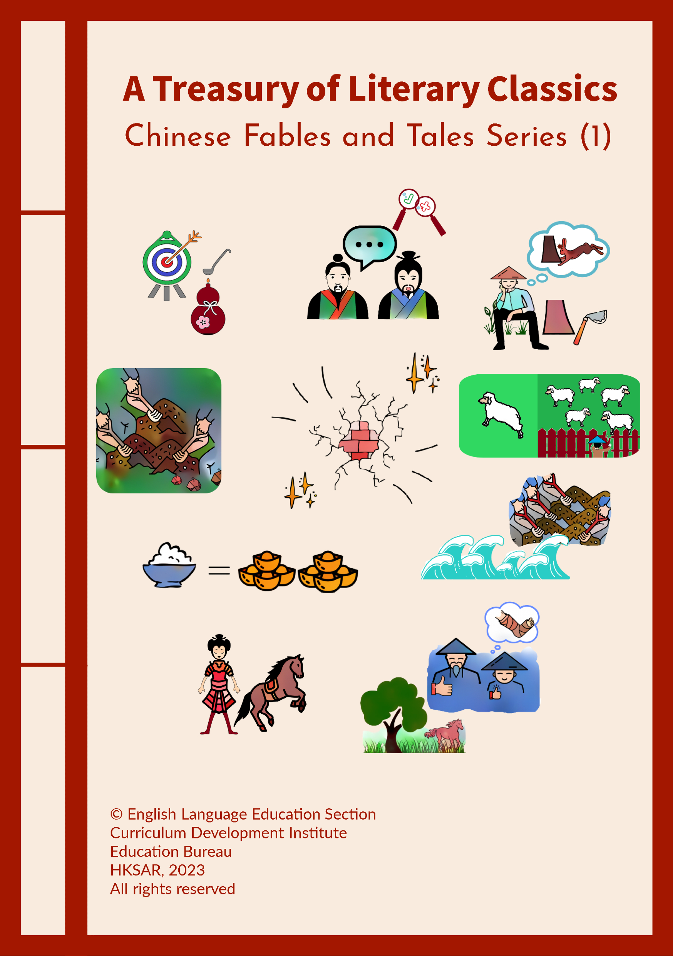

Answer Key

Chinese Fables and Tales Series (1)

China has a rich oral tradition with fables and tales passed down through thousands of years. Chinese fables and tales are timeless literary treasures. They are short fictional stories that deliver moral lessons through delightful characters such as humanised animals and exciting plots. These fantastic stories are used to promote positive and proper values and attitudes, such as gratitude, commitment, perseverance, honesty and respect for elders.

The ten Chinese stories selected in this series share the wisdom of human experience with great affection. They are tasters that aim to give students a glimpse into the time-honoured traditions and culture of China. The stories are supplemented with questions to enhance students’ reading skills and mastery of various language items as well as to guide them to reflect on the moral lessons. In addition, students are encouraged to watch a video* recommended in each story as an extension activity to help them develop an understanding of the latest development and achievements of China. Through the appreciation of the timeless stories and the recent development of China, a sense of national identity will be cultivated and positive and proper values and attitudes will be fostered in students.

The e-version of the series provides students with interactive functions such as answer-checking functions and prompts to facilitate self-directed learning. Teachers are encouraged to read some of these stories with students to increase their motivation, help them understand the wisdom embedded in the stories and guide them to apply positive and proper values and attitudes in their daily lives.

This set of resource materials is suitable for students at Key Stage 2 (Primary 4-6). Teachers, however, may recommend or select the stories with reference to their students’ needs and abilities to cater for learner diversity. Besides, the titles of some of these stories are well-known idiomatic expressions and sayings in the Chinese language. Students may read the original Chinese idioms. They may also read other Chinese fables and tales written in Chinese or English and learn the positive values and wisdom embedded in them.
*We are grateful to The China Current for the use of the videos on their website https://chinacurrent.com/.

English Language Education Section
Curriculum Development Institute
Education Bureau
The Hong Kong Special Administrative Region

12/F, Wu Chung House, 213 Queen’s Road East, Wan Chai, Hong Kong

Published 2023

The copyright of the materials in this series, other than the videos recommended in the Extension Activity, belongs to the Education Bureau of the Hong Kong Special Administrative Region.

Duplication of materials in this series other than the videos recommended in the Extension Activity is restricted to non-profit-making educational purposes only. In all cases, proper acknowledgements should be made. Otherwise, all rights are reserved, and no part of these materials may be reproduced, stored in a retrieval system, or transmitted in any form or by any means without the prior permission of the Education Bureau of the Hong Kong Special Administrative Region.

© 2023

Contents

Introduction | i

- Borrowing Light through Boring a Hole in the Wall | 1
- Mending the Fold after a Sheep is Lost | 7
- One Rice, Thousand Gold | 13
- Practice Makes Perfect | 19
- The Old Man Who Lost His Horse | 25
- The Story of Hua Mulan | 31
- Three Liars Make a Tiger | 37
- Waiting for More Hares to Dash Dead against the Stump | 43
- Yu Gong Moved away Two Mountains | 49
- Yu the Great Tamed the Waters | 55

Read the Chinese story and answer the following questions.

Borrowing Light through Boring a Hole in the Wall

1. During the Western Han Dynasty*, there was a prime minister named Kuang Heng, who was a well-known scholar. At that time, the tuition fees were extremely expensive. Only rich people were able to afford them, so there was no chance for kids from the grass-roots families to study. When Kuang Heng was a child, he was from a poor peasant family and could not afford to go to school, but he was very eager to read and learn.

2. Sometimes, Kuang Heng would sneak in the school to listen to the teacher's lectures after helping his parents at the farm. One day, the teacher came over to Kuang Heng and said, "You are here again." Kuang Heng said, "Yes, sir, I really want to learn. May I ask you, sir… can I acquire all the knowledge after listening to your lectures on these books?" The teacher shook his head, “No, no, no, these books are just a small part in the vast sea of ​​books. If you want to be a really useful person, you must read more books and bear what you have learnt in mind. I really appreciate your learning attitude. You can borrow a book from me every day and read it when you get home. If you don't understand, just ask me.” Kuang Heng was very grateful to the teacher. In the old days, books were very valuable, and people with books would not easily lend them to others.

3. After a few years, Kuang Heng grew up and became the sole income earner in his family. He had to work in the field all day long, and only when he rested at noon did he have time to do some reading. Therefore, it took him at least half a month to finish reading a book. Kuang Heng was very anxious about his learning progress and thought to himself, “I grow crops during the day and don't have time to read books. I have to spend more time on reading at night.”

4. However, Kuang Heng’s family was so poor that they could not afford lamp oil or candles. Although there were financial difficulties, the young boy never stopped pursuing his dream of studying. One night, while Kuang Heng was sitting on the bed reciting the book he had read during the day, he found that there was a ray of light coming through the wall. He stood up, walked to the wall and took a closer look. Ah! The neighbour's light came through the crack of the wall! Kuang Heng was overjoyed and thought of a way – he took a knife and dug the crack in the wall a bit bigger. In this way, more light shone through and he could read the books in this ray of light.

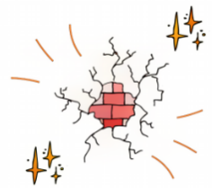
5. Thanks to the light coming through the wall, Kuang Heng could read a huge number of books to prepare for the imperial exams. Year by year, he passed each level, impressed the officials, and achieved his dream of becoming an imperial officer. Over the years, he held many prestigious titles and eventually became a famous scholar in Chinese history.
*The Western Han Dynasty refers to a dynasty in ancient Chinese history that ruled from 206 BC to 8 AD.

1. In paragraph 1, “Only rich people were able to afford them, so there was no chance for kids from the grass-roots families to study.” What does “grass-roots families” mean? It means …
a. families that are poor.
b. families that are rich.
c. families that grow crops.
d. families that raise horses.
Explanation/Hints:
Read paragraph 1.
“At that time, the tuition fees were extremely expensive. Only rich people were able to afford them, so there was no chance for kids from the grass-roots families to study.”

2. Why did Kuang Heng sneak in the school? He sneaked in the school because …
a. he was afraid of disturbing others.
b. he was not able to pay the tuition fees.
c. he was late for school.
d. he hadn’t finished his homework.
Explanation/Hints:
Read paragraph 1.
“When Kuang Heng was a child, he was from a poor peasant family and could not afford to go to school, but he was very eager to read and learn.”

3. Which of the following adjectives best describes the teacher?
a. Worried
b. Honest
c. Selfish
d. Supportive
Explanation/Hints:
Read paragraph 2.
“ ‘I really appreciate your learning attitude. You can borrow a book from me every day and read it when you get home. If you don't understand, just ask me.’ ”

4. Why would Kuang Heng start reading at night? He started reading at night because …
a. he thought he could concentrate better at night.
b. he was too lazy to read in the daytime.
c. he was too busy to read in the daytime.
d. he got the books from the teacher at night.
Explanation/Hints:
Read paragraph 3.
“Kuang Heng was very anxious about his learning progress and thought to himself, ‘I grow crops during the day and don't have time to read books. I have to spend more time on reading at night.’ ”

5. Which of the following adjectives best describe Kuang Heng?
(i) Grateful
(ii) Perseverant
(iii) Arrogant
(iv) Diligent
a. (i) & (iii)
b. (i), (ii) & (iv)
c. (ii), (iii) & (iv)
d. All of the above
Explanation/Hints:
How did Kuang Heng feel towards his teacher as his teacher lent him books to read?
How was Kuang Heng in the face of adversity? Did he give up easily or try to be lazy?
What did Kuang Heng do to keep up with his learning progress?

6. What was NOT TRUE about Kuang Heng?
a. Kuang Heng had to work on the farm in the daytime.
b. Kuang Heng read the books at night so as to keep up with the learning progress.
c. Kuang Heng’s parents saved enough money to buy candles for him.
d. Kuang Heng never stopped pursuing his dream of studying.
Explanation/Hints:
Read paragraph 4.
“However, Kuang Heng’s family was so poor that they could not afford lamp oil or candles.”

- A connective joins words or sentences together. For example, “Kuang Heng grew up and became the sole income earner in his family.” “And” is used to link the two sentences together, which are “Kuang Heng grew up.” and “Kuang Heng became the sole income earner in his family.”

Read the following descriptions. Fill in each blank with a connective from the list given. Each option can be used once only.

A. so B. although C. if D. while

 | Description | Connective
7a. | ______ Kuang Heng was lying on the bed reciting the book he had read during the day, he found that there was a ray of light coming through the wall. | ( D )
7b. | ______ you want to be a really useful person, you must read more books and bear what you have learnt in mind. | ( C )
7c. | Only rich people were able to afford the tuition fees, ______ there was no chance for kids from the grass-roots families to study. | ( A )
7d. | ______ there were financial difficulties, the young boy never stopped pursuing his dream of studying. | ( B )

Explanation/Hints:
A. We use “so” to show the result or purpose of the action taken.
B. We use “although” to connect contrasting ideas.
C. We use “if” to talk about a particular thing that can or will happen only after something else becomes true.
D. We use “while” to talk about two things happening at the same time.

8. What did Kuang Heng do when he saw a ray of light coming through the wall?
a. He took a closer look at the crack and mended it.
b. He was overjoyed and told his neighbour.
c. He sat closer to the crack and continued reading.
d. He dug the crack so as to enlarge it and read in this brighter light.
Explanation/Hints:
Read paragraph 4.
“The neighbour's light came through the crack of the wall! Kuang Heng was overjoyed and thought of a way – he took a knife and dug the crack in the wall a bit bigger.”

9. How did Kuang Heng become an imperial officer?
a. He was able to discover different ways to grow crops.
b. He taught the officials effective ways to fight against the pests.
c. He studied extremely hard and successfully passed the imperial exams.
d. His perseverance and diligence touched the emperor.
Explanation/Hints:
Read paragraph 5.
“Thanks to the light coming through the wall, Kuang Heng could read a huge number of books to prepare for the imperial exams. Year by year, he passed each level, impressed the officials, and achieved his dream of becoming an imperial officer.”

10. What is the moral lesson of the story? Based on the story, which Chinese saying can you think of?

11. Kuang Heng was very diligent and determined in his study and demonstrated perseverance in the face of adversity. We have abundant resources nowadays, but do you treasure them, make good use of them and work very hard to pursue your dream? Think and share your ideas or experiences with your parents or classmates.

Extension Activity

Watch the video clip “24 Hours of Sun”, which is about the development of new technology in China to harness the sun’s power 24 hours a day. In China, solar energy is being implemented at a rapid pace. With the use of molten salt technology, solar power can be generated continuously day and night.

https://chinacurrent.com/story/20749/24-hours-of-sun

The new green technology also helps cut down tons of carbon emissions every year and achieve carbon neutrality in the future. Are there other examples about technology which helps improve the quality of life? Think and share your ideas or experiences with your parents or classmates.

Read the Chinese story and answer the following questions.

Mending the Fold after a Sheep is Lost

1. During the Warring States Period*, the State of Chu was weak. The King of Chu and the important court officials spent most of their time enjoying a luxurious life. Zhuang Xin, one of the ministers, knew that the State of Chu was in danger because a lot of enemies wanted to attack the territory.

2. One day, Zhuang Xin made up his mind and went to the King’s palace. He sincerely hoped that the King of Chu would listen to his advice to pay more attention to guarding the territory. However, the King clenched his fists and yelled, “How dare you! You curse my territory! No one can take my power away!” Zhuang Xin was depressed and felt that the King was incompetent. He asked the King to let him leave. He then went to the State of Zhao and stayed there for a while.

3. Within six months, the King of Qin sent his troops to invade the State of Chu and occupied the territory. The King of Chu escaped to a smaller city “Yang”. He remembered Zhuang Xin’s words and was regretful for not taking his advice. He sent his officials to invite Zhuang Xin back to help him. When the King saw Zhuang Xin, he asked, “What can I do now? I lost my territory.” Zhuang Xin replied, “Let me tell you a story. You may know what to do.”

4. Zhuang Xin said, “A shepherd woke up one morning and found that there was a hole in his pen. When he counted his sheep, he realised that one of his sheep was lost. The shepherd immediately chased his lost sheep but forgot to block the hole. Fortunately, the shepherd’s wife used her body to block the hole. When the shepherd returned with the lost sheep, he mended the hole in the fence at once.”

5. “We did lose our territory but if we reform now and strengthen our army, we still have a chance to get it back,” said Zhuang Xin. The King of Chu was very pleased and took Zhuang’s advice. The next year, the King of Chu successfully won his territory back.
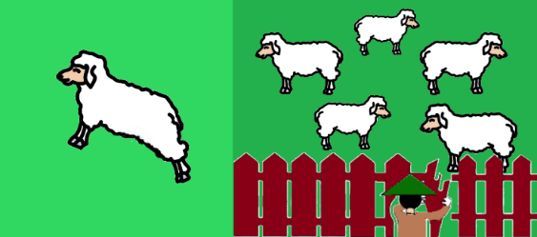
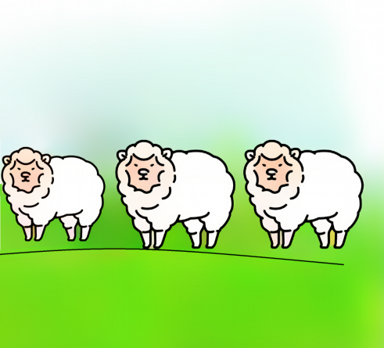
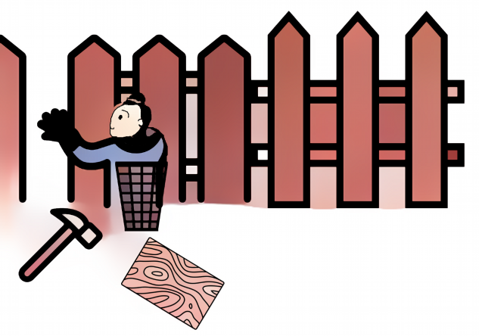

*The Warring States Period refers to a period of time (475 BC – 221 BC) in ancient history characterised by warfare.
- Why did Zhuang Xin leave the King?
- The King paid too much attention to guarding his territory.
- The King played and enjoyed his life all the time.
- The King asked Zhuang Xin to build the guarded wall for him.
- The King left his people behind and escaped to another city.
Explanation/Hints:
What did the King do all the time?
Read paragraph 1.
“The King of Chu and the important court officials spent most of their time enjoying a luxurious life.”

- What happened to the King’s territory?
- The King’s territory became stronger and bigger.
- The King’s territory became part of Yang’s place.
- The King’s enemies invaded the territory.
- Zhuang Xin ruled the territory for the King.
Explanation/Hints:
Who sent the troops to invade the King’s territory?
Read paragraph 3.
“Within six months, the King of Qin sent his troops to invade the State of Chu and occupied the territory.”

- How did the King feel when he escaped to a smaller city “Yang”?
- The King felt sorry about losing his own territory.
- The King felt excited about leaving his own territory.
- The King felt astonished about the size of the city “Yang”.
- The King felt worried about living in the smaller city “Yang”.
Explanation/Hints:
How did the King think about Zhuang’s last words?
Read paragraph 3.
“The King of Chu escaped to a smaller city ‘Yang’. He remembered Zhuang Xin’s words and was regretful for not taking his advice.”

- What did the King do after he remembered Zhuang’s words?
- The King comforted himself by laughing all the time.
- The King tried to find Zhuang Xin in the city “Yang”.
- The King tried to invite Zhuang Xin back to help him.
- The King cried all the time about losing Zhuang Xin.
Explanation/Hints:
Who did the King ask for help?
Read paragraph 3.
“He sent his officials to invite Zhuang Xin back to help him.”

- What had happened in the story told by Zhuang Xin?
- There was a very big hole in the pen.
- A sheep escaped but the shepherd got it back.
- The shepherd’s wife chased the lost sheep.
- The shepherd blocked the hole with his body.
- (i) & (ii)
- (i), (ii) & (iii)
- (ii) & (iv)
- (ii), (iii) & (iv)
Explanation/Hints:
What did the shepherd and his wife do?
Read paragraph 4.
“Zhuang Xin said, ‘A shepherd woke up one morning and found that there was a hole in his pen. When he counted his sheep, he realised that one of his sheep was lost. The shepherd immediately chased his lost sheep but forgot to block the hole. Fortunately, the shepherd’s wife used her body to block the hole. When the shepherd returned with the lost sheep, he mended the hole in the fence at once.’ ”

- What advice did Zhuang Xin give to the King using the story?
- Zhuang Xin encouraged the King to change and win the territory back.
- Zhuang Xin discouraged the King from getting the territory back.
- Zhuang Xin wanted the King to become a shepherd instead of a king.
- Zhuang Xin wanted the King to get the territory back with his body.
Explanation/Hints:
What did Zhuang Xin say to the King?
Read paragraph 5.
“ ‘We did lose our territory but if we reform now and strengthen our army, we still have a chance to get it back,’ said Zhuang Xin.”
- Prefixes are letters which we add to the beginning of a word to make a new word with a different meaning. They can make a word negative, such as “impolite” (an adjective which means “bad manners”) or “misunderstand” (a verb which means “fail to understand something or someone”). We use these prefixes most commonly in negation, e.g. ir-, un-, dis-, in-.

Read the following descriptions. Turn each of the underlined words into the negative meaning by choosing a prefix from the list given. Each option can be used once only.

- ir B. un C. dis D. in

 | Description | Prefix
7a. | Zhuang Xin warned the King about the enemies, but the King didn’t listen to him. The King was attentive to his advice. | ( D )
7b. | Zhuang Xin left the King because the King did not care about his people and the territory. Zhuang Xin thought that the King was very ________responsible. | ( A )
7c. | In the story told by Zhuang Xin, the shepherd was _lucky because a sheep escaped from the hole. | ( B )
7d. | Zhuang Xin was pleased with the way the King ruled his territory at first. Nevertheless, he was glad that the King finally decided to reform. | ( C )

Explanation/Hints:
Look these words up in the dictionary if necessary.

- From the way Zhuang Xin encouraged the King to reform, which adjectives best describe Zhuang Xin?
- Loyal and thoughtful
- Quiet and kind
- Pessimistic and mean
- Selfish and impatient
Explanation/Hints:
Did Zhuang Xin give up advising the King?
What did he say to the King?

- Why could the King of Chu (the King) win his territory back? Complete the text about how the King got the territory back by choosing the correct names of persons provided below.

“(i) _____________ was loyal to his country. He felt the King was not responsible and advised him to guard his territory. However, the King did not listen to his advice. When (ii)____________ invaded the State of Chu, the King was regretful and invited (iii)_____________ back. He told the King a story which inspired (iv) _____________ to transform and strengthen the State of Chu, and be committed to his territory and people. With their concerted effort, the King successfully won the whole territory back.”

- (i) Zhuang Xin, (ii) the King, (iii) The King of Qin, (iv) the King
- (i) the King of Qin, (ii) Zhuang Xin, (iii) the King of Qin, (iv) the King
- (i) The King, (ii) the King of Qin, (iii) the King, (iv) Zhuang Xin
- (i) Zhuang Xin, (ii) the King of Qin, (iii) Zhuang Xin, (iv) the King
Explanation/Hints:
What did Zhuang Xin say to the King?
What was the King’s major concern at that time?
What did he do then?
Read paragraph 5.
“ ‘We did lose our territory but if we reform now and strengthen our army, we still have a chance to get it back,’ said Zhuang Xin. The King of Chu was very pleased and took Zhuang’s advice. The next year, the King of Chu successfully won his territory back.”

- What is the moral lesson of the story? Based on the story, which Chinese saying can you think of?

- Have you ever made any mistakes? What lessons did you learn from the mistakes? Think of one incident and share what you learnt from it with your parents or classmates.

Extension Activity

Watch the video clip “Bringing Tech to the Countryside”, which is about the importance of helping rural people in China to catch up with the world by introducing them to technology.

https://chinacurrent.com/story/23257/bringing-tech-to-the-countryside

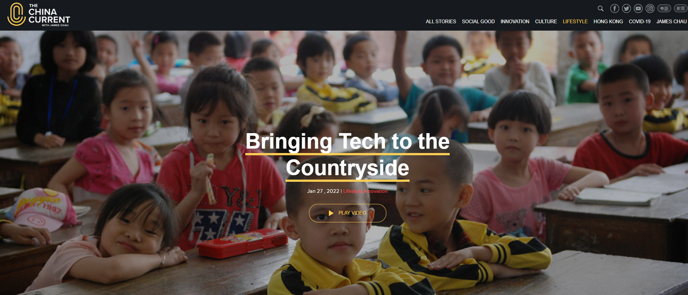

With a big shift to learning and living digitally in this information age, China is helping children and people in rural areas to be able to access online through installing internet hubs and expanding cellular coverage. Why is it important to bring technology to people in the countryside? What should we do to prepare ourselves for the opportunities that may arise? Think and share your ideas or experiences with your parents or classmates.

Read the Chinese story and answer the following questions.

One Rice, Thousand Gold

1. Long ago in ancient China, there was a poor young man named Han Xin. When he did not have enough food to eat, he went to the river to catch fish. However, he was usually empty-handed. He always had to suffer from hunger.

2. One day, some old women were washing clothes in the river. One of the old women saw Han Xin and came over to him. “Poor young man, you look so thin! You are as skinny as the fishing pole. Please have a bowl of rice,” said the old woman.

3. “Thank you so much!” replied Han Xin. He bowed down to the old woman politely. From then on, the old woman would give Han Xin some rice to eat when she saw him. Han Xin was very grateful to her and said, “I will find a way to pay you back someday.” “Young man, I don’t expect you to repay me. You should find a way to support yourself and remember to help others,” smiled the old woman. Han Xin nodded and was determined to work hard in return for the old woman.

4. Later, Han Xin joined the army and helped his master Liu Bang by giving him a lot of strategic advice. The emperor of the Qin Dynasty was eventually overthrown. Han Xin was given land and conferred kingship by Liu Bang, who became the first emperor of the Han Dynasty. Han Xin remembered the words of the old woman and wanted to thank her for her kindness. Therefore, he went back to the village and tried to look for her. At last, Han Xin found the old woman in a small house and invited her to his palace.

5. “I promised I would pay you back someday. Please take the gold,” said Han Xin. He bowed down and gave the old woman a big bowl of gold! “Thank you for the gold, but I don’t need it. You have already paid me back by becoming a strong and kind king now,” smiled the old woman.

- What problem did Han Xin face when he was a young man?
- Han Xin did not have enough food to eat.
- Han Xin did not have enough clothes to wear.
- Han Xin could not go fishing with his family.
- Han Xin did not have toys to play with.
Explanation/Hints:
Read paragraph 1.
“When he did not have enough food to eat, he went to the river to catch fish. However, he was usually empty-handed. He always had to suffer from hunger.”

- What did young Han Xin do to solve his problem?
- Han Xin walked around the village and begged people for food.
- Han Xin helped the old woman wash her clothes for money.
- Han Xin went down to the river to try to catch some fish.
- Han Xin cooked rice for the old woman to earn some money.
Explanation/Hints:
Where did Han Xin go?
Read paragraph 1.
“When he did not have enough food to eat, he went to the river to catch fish. However, he was usually empty-handed. He always had to suffer from hunger.”

- What did the old woman do to Han Xin?
- The old woman gave Han Xin some fish.
- The old woman gave Han Xin some rice.
- The old woman gave Han Xin some clothes.
- The old woman gave Han Xin some gold.
Explanation/Hints:
What did the old woman give to Han Xin?
Read paragraph 2.
“ ‘Poor young man, you look so thin! You are as skinny as the fishing pole. Please have a bowl of rice,’ said the old woman.”

- Why was Han Xin very grateful to the old woman?
- The old woman gave Han Xin some rice every time she saw him.
- The old woman did not expect Han Xin to repay her at all.
- The old woman encouraged Han Xin to become a kind and helpful man.
- All of the above.
Explanation/Hints:
What did the old woman do and say to Han Xin?
Read paragraph 3.
“From then on, the old woman would give Han Xin some rice to eat when she saw him.”
“ ‘Young man, I don’t expect you to repay me. You should find a way to support yourself and remember to help others,’ smiled the old woman.”

- What did Han Xin promise the old woman?
- Han Xin promised to pay the old woman back in the future.
- Han Xin promised to cook some food for the old woman.
(iii) Han Xin promised to wash the clothes for the old woman.
(iv) Han Xin promised the old woman to work hard in the future.
- (i) & (iv)
- (i), (iii) & (iv)
- (ii) & (iii)
- (ii), (iii) & (iv)
Explanation/Hints:
What did Han Xin decide to do?
Read paragraph 3.
“Han Xin was very grateful to her and said, ‘I will find a way to pay you back someday.’ ‘Young man, I don’t expect you to repay me. You should find a way to support yourself and remember to help others,’ smiled the old woman. Han Xin nodded and was determined to work hard in return for the old woman.”

- What was Han Xin when he grew up?
- Han Xin became a fisherman.
- Han Xin became a farmer.
- Han Xin became a king.
- Han Xin became a beggar.
Explanation/Hints:
What was his title?
Read paragraph 4.
“Later, Han Xin joined the army and helped his master Liu Bang by giving him a lot of strategic advice. The emperor of the Qin Dynasty was eventually overthrown. Han Xin was given land and conferred kingship by Liu Bang, who became the first emperor of the Han Dynasty.”

- Suffixes are letters which we add at the end of a word to make a new word. The new word is often a different word class from the original word. The suffix “-ness” is added to adjectives to form nouns that refer to quantities or conditions.

Read the following descriptions. Fill in each blank with a noun from the list given. Each option can be used once only.

- humbleness B. toughness C. politeness D. willingness

 | Description | Noun
7a. | The man had a difficult life when he was young. However, the ____________ of his early life taught him to become a kind person. | ( B )
7b. | The old woman was willing to give the young man some rice to eat. Her ____________ and generosity saved him from hunger. | ( D )
7c. | The young man thanked the old woman politely for giving him the rice. She was touched by his ____________, and encouraged him to be kind. | ( C )
7d. | Han Xin bowed down to the old woman. His acts of __________ showed that he was a grateful person. | ( A )

Explanation/Hints:
Read the sentences carefully to understand their meanings.

- Where did Han Xin find the old woman?
- Han Xin found the old woman near the river.
- Han Xin found the old woman in the village.
- Han Xin found the old woman in the army.
- Han Xin found the old woman in the palace.
Explanation/Hints:
Where did Han Xin go?
Read paragraph 4.
“Therefore, he went back to the village and tried to look for her. At last, Han Xin found the old woman in a small house and invited her to his palace.”

- Why did the old woman not take the gold from Han Xin?
- The old woman was not interested in gold at all but she liked beautiful clothes only.
- Han Xin followed the old woman’s advice and became a strong and kind man and a good king.
- The old woman was sad that Han Xin did not give her enough gold.
- The old woman was so old that she was unable to take the gold away by herself.
Explanation/Hints:
What did the old woman say to Han Xin?
Read paragraph 5.
“ ‘Thank you for the gold, but I don’t need it. You have already paid me back by becoming a strong and kind king now,’ smiled the old woman.”

- What is the moral lesson of the story? Based on the story, which Chinese saying can you think of?

- What should we do when we are able to offer help to people who are in need? Think and share your ideas or experiences with your parents or classmates.

Extension Activity

Watch the video clip “Growing Rice as a Way to Solve Hunger”, which is about some Chinese researchers sharing the knowledge and techniques of growing rice with other countries to solve the problem of hunger.

https://chinacurrent.com/story/23588/growing-rice-as-a-way-to-solve-hunger

What do you think about offering help to people who are in need? Should we expect anything in return when we do favours for others? Think and share your ideas or experiences with your parents or classmates.

Read the Chinese story and answer the following questions.

Practice Makes Perfect

1. In the Northern Song Dynasty*, a young man called Chen Yaozi was one of the best archers in his village. All the villagers cheered and praised him for his remarkable archery skills. He was very proud of himself.

2. One day, when Chen Yaozi was shooting arrows in his garden, an old pitchman passed by. He put down the oil he was carrying and looked closely at Chen Yaozi. Seeing that Chen Yaozi hit the target eight or nine times out of ten arrows, the old pitchman just nodded slightly without giving him praises.

3. Chen Yaozi was disappointed that the old pitchman did not praise him. He asked the old pitchman, “Do you know archery as well? Aren’t my skills brilliant?” The old pitchman replied, “This is nothing, only skilful technique.” Chen’s face got red. He shouted, “How dare you comment on my archery?” The old pitchman responded calmly, “I know this just based on my experience in pouring oil.”

4. The old pitchman then took out a bottle gourd from his basket and placed it on the ground. He covered the opening of the gourd with a coin which had a small square hole in the centre. He scooped a spoonful of oil with a ladle, and slowly poured the oil into the gourd through the small square hole in the coin. Not even a single drop of oil was found on the surface of the coin. Chen Yaozi was amazed to see how skilful the old pitchman was.

5. The old pitchman said, “This is nothing. I have just been pouring oil for a long time. Practice makes perfect.” Chen Yaozi was embarrassed and apologised to the old pitchman. “From then on, I must practise very hard to further improve my archery skills with modesty,” said Chen Yaozi.

*The Northern Song Dynasty refers to a dynasty in ancient Chinese history that ruled from 960 AD to 1127 AD.
- Read paragraph 1. Chen Yaozi was ___________.
- an archer
- a pitchman
- a viewer
- a teacher
Explanation/Hints:
Read paragraph 1.
“In the Northern Song Dynasty, a young man called Chen Yaozi was one of the best archers in his village.”

- As stated in paragraph 2, how many times did Chen Yaozi hit the target?
- Chen Yaozi hit the target with four or five out of ten arrows.
- Chen Yaozi hit the target with eight or nine out of twenty arrows.
- Chen Yaozi hit the target with eight or nine out of ten arrows.
- Chen Yaozi hit the target with six or seven out of twenty arrows.
Explanation/Hints:
Read the numbers in paragraph 2.
“Seeing that Chen Yaozi hit the target eight or nine times out of ten arrows, the old pitchman just nodded slightly without giving him praises.”

- How did people think about Chen’s archery?
- People thought that Chen’s archery was poor.
- People thought that Chen’s archery was average.
- People thought that Chen’s archery was slightly above average.
- People thought that Chen’s archery was excellent.
Explanation/Hints:
What did people say?
Read paragraph 1.
“All the villagers cheered and praised him for his remarkable archery skills.”

- How did Chen Yaozi feel about people’s reaction?
- Chen Yaozi was sorry about people’s reaction.
- Chen Yaozi was worried about people’s reaction.
- Chen Yaozi was contented with people’s reaction.
- Chen Yaozi was embarrassed with people’s reaction.
Explanation/Hints:
Read paragraph 1.
“All the villagers cheered and praised him for his remarkable archery skills. He was very proud of himself.”

5. Which of the following sentences are TRUE about the old pitchman?
(i) The old pitchman knew little about archery.
(ii) The old pitchman sold mainly oil, arrows and copper coins.
(iii) The old pitchman thought Chen Yaozi had remarkable archery skills.
(iv) The old pitchman believed that practice could improve skills.
- (i) & (iv)
- (i), (ii) & (iii)
- (ii) & (iii)
- (ii), (iii) & (iv)
Explanation/Hints:
What did the old pitchman say and do to Chen Yaozi?

- There was not a drop of oil beyond the coin hole. How could the old pitchman do that?
- The old pitchman had secrets behind.
- The old pitchman played tricks on Chen Yaozi.
- The old pitchman had practised very hard.
- The old pitchman did not pour the oil at all.
Explanation/Hints:
What did the old pitchman say?
Read paragraph 5.
“The old pitchman said, ‘This is nothing. I have just been pouring oil for a long time. Practice makes perfect.’ ”

- Some verbs ending with the suffix “-ed” or “-d” become adjectives which are used to describe a person’s feelings, such as “annoyed” and “amazed”.

Read the following descriptions. Fill in each blank with an adjective from the list given. Each option can be used once only.

- embarrassed B. frustrated C. inspired D. disappointed

 | Description | Adjective
7a. | The old pitchman did not think that Chen had remarkable archery skills. Chen was ___________ about his comment because he thought the old pitchman would praise him. | ( D )
7b. | Chen was very when he learnt that the old pitchman could pour the oil so well. He knew that he could never perform the same as the old pitchman. | ( B )
7c. | Chen replied to the old pitchman by saying, “How dare you comment on my archery?” When he noticed how professional the old pitchman was, he felt really . He was sorry about his rudeness. | ( A )
7d. | Chen was by the old pitchman’s act and realised the importance of frequent practice. | ( C )

Explanation/Hints:
Read the sentences carefully to understand their meanings.

8. What did Chen Yaozi learn from the old pitchman?
a. Chen Yaozi learnt to practise archery hard.
b. Chen Yaozi learnt nothing from the old pitchman.
c. Chen Yaozi learnt the skills from the old pitchman.
d. Chen Yaozi learnt to practise archery occasionally.
Explanation/Hints:
How did he feel after seeing the old pitchman’s demonstration?
Read paragraph 5.
“Chen Yaozi was embarrassed and apologised to the old pitchman. ‘From then on, I must practise very hard to further improve my archery skills with modesty,’ said Chen Yaozi.”

9. Which is NOT TRUE about the story?
a. The story took place in the Northern Song Dynasty in China.
b. Chen Yaozi had an archery competition with the old pitchman the next day.
c. The old pitchman showed Chen Yaozi how to pour the oil skilfully.
d. Chen Yaozi was no longer complacent and committed himself to practising hard from then on.
Explanation/Hints:
Did Chen Yaozi have a competition with the old pitchman?
Did he feel ashamed when he saw the old pitchman pour the oil?
Did he practise archery with modesty from then on?
Who was he committed to?

10. What is the moral lesson of the story? Based on the story, which Chinese saying can you think of?

11. Have you ever had experiences in which practice makes perfect? Think of one incident and share it with your parents or classmates.

Extension Activity

Watch the video clip “Meet This Olympic Champion”, which is about how an Olympic champion, Yang Qian, overcame her difficulties through perseverance and resilience.

https://chinacurrent.com/story/22394/meet-this-olympic-champion

Why did Yang Qian’s tutor choose her to receive training as a sport shooter? What did she do when her mother was seriously ill during her study in the university? Did she practise hard to make her dream come true? Think and share your ideas or experiences with your parents or classmates.

Read the Chinese story and answer the following questions.

The Old Man Who Lost His Horse

1. There used to be an old man who raised horses for a living. Everyone called him Sai Weng. He lived with his son on the outskirts of the country. Both of them enjoyed riding horses.

2. One day, a horse escaped from Sai Weng’s stable and ran across to the neighbouring country. When the neighbours learnt about the misfortune of Sai Weng, they all came to comfort him so that he would not feel too sad, “Alas, how unfortunate to lose such a fine horse!” Unexpectedly, Sai Weng was not sad at all. He simply smiled and said, "Although my horse is lost, it might be a good thing."

3. After a few months, the lost horse returned, together with a beautiful and strong female horse alongside him. When the neighbours heard about this, they ran to Sai Weng’s house to congratulate him, “Congratulations, my old friend! You are so lucky to have your lost horse back and gain another nice one,” exclaimed the old man’s neighbours. However, Sai Weng frowned this time and said to everyone, "It might not be a good thing to have this horse."

4. Sai Weng’s son liked riding horses very much. One day, he went out for a ride on the fine new horse. However, the new horse got frightened by a wild animal and threw him from her back. Having broken his leg badly, he was not able to walk again. The neighbours knew about the bad news and they came to Sai Weng’s house again to comfort him. Unexpectedly, Sai Weng said to everyone calmly, “Although my son broke his leg, it might be a good thing.” Everyone found it inexplicable. They thought Sai Weng must be too sad and confused.

5. Soon after, the emperor’s army recruited all able-bodied young men to fight a war. As the enemies were very belligerent, most of the young men died on the battlefield. Sai Weng’s son didn’t join the army because of his injury. Therefore, his life was saved. Only then did the neighbours realise the wisdom implied in the words Sai Weng said.

6. What happens in life is hard to predict. A fortune can be a curse, whereas a misfortune can be a blessing. Therefore, don’t be overjoyed by the fortune you get by chance, and don’t be too proud when you encounter things that go well. Meanwhile, don’t be too negative and pessimistic when you encounter frustrations and setbacks as they may turn out to be good and advantageous. They may be a blessing in disguise.

1. What did Sai Weng do for a living?
a. He took care of horses.
b. He raced horses.
c. He rode horses.
d. He trained horses.
Explanation/Hints:
Read paragraph 1.
“There used to be an old man who raised horses for a living. Everyone called him Sai Weng.”

2. In paragraph 2, “When the neighbours learnt about the misfortune of Sai Weng, they all came to comfort him so that he would not feel too sad…” What does “misfortune” mean? It means…
a. a pleasant event.
b. an unlucky event.
c. an annoying event.
d. a funny event.
Explanation/Hints:
Read paragraph 2.
Read the sentence carefully. Why did the neighbours comfort Sai Weng?

3. Which of the following adjectives best describes Sai Weng when he knew he lost one of his most valuable horses?
a. Upset
b. Brave
c. Worried
d. Calm
Explanation/Hints:
Read paragraph 2.
“Unexpectedly, Sai Weng was not sad at all. He simply smiled and said, ‘Although my horse is lost, it might be a good thing.’ ”

4. How did the old man’s friends and neighbours feel when they knew that the old man’s lost horse returned with another fine horse?
a. Peaceful
b. Jealous
c. Joyful
d. Scared
Explanation/Hints:
Read paragraph 3.
“When the neighbours heard about this, they ran to Sai Weng's house to congratulate him, ‘Congratulations, my old friend! You are so lucky to have your lost horse back and gain another nice one,’ exclaimed the old man’s neighbours.”

5. What happened to the old man’s son when he went out for a ride on the fine new horse?
a. He had gone missing with the new horse.
b. He fell from the horse and broke his leg.
c. He went to the neighbouring country.
d. He met his friends and neighbours.
Explanation/Hints:
Read paragraph 4.
“One day, he went out for a ride on the fine new horse. However, the new horse got frightened by a wild animal and threw him from her back. Having broken his leg badly, he was not able to walk again.”

6. When Sai Weng’s son got injured, Sai Weng said it might be a good thing. What did his neighbours think about this?
a. They agreed with what Sai Weng said.
b. They appreciated that Sai Weng had a positive mind.
c. They found it difficult to understand.
d. They were sad about what Sai Weng said.
Explanation/Hints:
Read paragraph 4.
“Unexpectedly, Sai Weng said to everyone calmly, ‘Although my son broke his leg, it might be a good thing.’ Everyone found it inexplicable. They thought Sai Weng must be too sad and confused.”

7. An interjection is a word that is used to show a short sudden expression of emotion. For example, “Alas, how unfortunate to lose such a fine horse!” The word “alas” is used to express sadness or pity when one feels sorry about something.

Read the following descriptions. Fill in each blank with an interjection from the list given. Each option can be used once only.

A. Oh B. Phew C. Wow D. Ouch

 | Description | Interjection
7a. | “______! What a beautiful horse! You are so lucky to have your lost horse back and gain another nice one,” exclaimed the old man’s friends and neighbours. | ( C )
7b. | “______! My leg is very painful! Please help!” shouted the old man’s son. | ( D )
7c. | “______ ... We are so sorry to hear that your son has lost his leg at such a young age,” the old man’s friends and neighbours sighed. | ( A )
7d. | “______! I don’t have to join the army. How lucky I am!” said the old man’s son. | ( B )

Explanation/Hints:
- “Oh” is used to show emotions such as surprise, sadness and pleasure.
- “Phew” is used when you are happy and relieved that something difficult or dangerous has finished or is not going to happen.
- “Wow” is used to show surprise or pleasure.
- “Ouch” is used to show sudden physical pain.

8. The old man’s son didn’t need to join the army because…
a. he was too young.
b. he didn’t know how to fight.
c. he was too sick.
d. he was not able to walk.
Explanation/Hints:
Read paragraphs 5.
“Soon after, the emperor’s army recruited all able-bodied young men to fight a war … Sai Weng’s son didn’t join the army because of his injury.”

9. Read paragraph 6. What does “a blessing in disguise” mean? It means that…
a. people cannot stop the passing of time, and therefore should not delay doing things.
b. we should be grateful for the good things in our lives and stop being too unhappy about the bad things.
c. we should be optimistic about ups and downs in our lives as something that seems bad at first may result in something good later.
d. something that seems good at first, but results in something bad happening later.
Explanation/Hints:
Read paragraph 6.
“Meanwhile, don’t be too negative and pessimistic when you encounter frustrations and setbacks as they may turn out to be good and advantageous. They may be a blessing in disguise.”

10. What is the moral lesson of the story? Based on the story, which Chinese saying can you think of?

11. Have you ever experienced any seemingly bad situation but it turned out to be something good for you? Think of one incident and share it with your parents or classmates.

Extension Activity

Watch the video clip “The Keys to Making a Piano”, which is about how a small town called Luoshe and its 10,000 people transformed their piano manufacturing industry into a global centre for music.

https://chinacurrent.com/story/20287/the-keys-to-making-a-piano

Loushe traditionally dealt with piano wholesalers. However, most of the companies turned their business to offering products directly to end-use consumers during the pandemic. The change has helped the town to become a centre of classical music. What have you learnt from the people there? Think and share your ideas or experiences with your parents or classmates.

Read the Chinese story and answer the following questions.

The Story of Hua Mulan

1. Many, many years ago in ancient China, there was a beautiful girl named Hua Mulan. Mulan’s father was a retired general whose leg had been injured in a battle. Sick and frail, he was too old to fight, but still, he insisted on teaching Mulan how to ride a horse and use a sword. It was not common for girls to learn these skills in the old days. However, Mulan’s father believed that everyone should know how to fight, even girls.

2. One day, the war news came like a bolt from the blue. The emperor had ordered that one man from every family MUST join the army. Mulan knew that her father was too old to fight while her brother was just a young child. There was only Mulan who could replace her father to serve the country. However, the military did not take girls as replacements for soldiers. Mulan was very anxious and tried to think of a way out. She decided that she could disguise herself as a man and join the army to take her father’s place. Early next morning, when her parents were still sleeping, Mulan put on her father’s armour and reported for duty secretly.

3. When Mulan arrived at the barracks, she trained with the soldiers and worked hard to adapt to the life there. At the beginning, Mulan struggled to keep up and she was very frustrated. Nevertheless, she faced all the challenges positively, and with determination and perseverance, she excelled in martial arts and made great achievements in devising strategies to beat back the enemies. Mulan was very careful over the years, so no one ever suspected that she was a girl.

4. Mulan's reputation for bravery reached the emperor's ears, and he was very grateful to Mulan, even after Mulan confessed that she was a woman. When the war came to an end, the emperor asked her to stay on as his adviser, but Mulan knew it was time for family reunion. Therefore, the emperor gave her a horse and a bagful of wealth as awards, and sent some soldiers to escort her home.

5. Mulan’s family greeted Mulan with great joy. They prepared a big feast for her to celebrate. Mulan returned to her room, combed her hair and put on the clothes of a woman. The soldiers who escorted Mulan back could not believe their eyes and shouted, “Who are you? Where is Mulan?” After Mulan had recounted many memories, they finally believed that Mulan was a woman who had fought by their side in many battles, in which they narrowly escaped death.

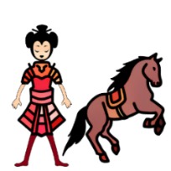
6. The story of Mulan disguising herself as a man and replacing her father to serve in the army soon spread across China, and her virtue of filial piety was highly praised by people.

1. Read paragraph 1. Mulan knew how to fight because…
a. she learnt it in the army.
b. her father taught her.
c. she learned it by herself.
d. the military leader trained her.
Explanation/Hints:
Read paragraph 1.
“Sick and frail, he was too old to fight, but still, he insisted on teaching Mulan how to ride a horse and use a sword. It was not common for girls to learn these skills in the old days. However, Mulan’s father believed that everyone should know how to fight, even girls.”

2. What kind of people didn’t the military take for fighting the war?
a. Old men
b. Sick people
c. Women
d. Retired generals
Explanation/Hints:
Read paragraph 2.
“However, the military did not take girls as replacements for soldiers.”

3. What did Mulan do after she saw her father’s name on the list?
a. She encouraged her brother to join the army.
b. She disguised herself as a man and joined the army.
c. She told her father that she would report for duty for him.
d. She told the government officials that her father was sick.
Explanation/Hints:
Read paragraph 2.
“Mulan was very anxious and tried to think of a way out. She decided that she could disguise herself as a man and join the army to take her father’s place. Early next morning, when her parents were still sleeping, Mulan put on her father’s armour and reported for duty secretly.”

4. Why did Mulan receive awards from the emperor? She received the awards because …
a. she worked industriously at home.
b. she studied attentively in the army.
c. she tried her best to protect the country.
d. she greeted and served the emperor respectfully.
Explanation/Hints:
Read paragraph 4.
“Mulan's reputation for bravery reached the emperor's ears, and he was very grateful to Mulan, even after Mulan confessed that she was a woman. When the war came to an end, the emperor asked her to stay on as his adviser, but Mulan knew it was time for family reunion. Therefore, the emperor gave her a horse and a bagful of wealth as awards, and sent some soldiers to escort her home.”

5. From what Mulan did for her family and her performance in the army, which adjectives best describe her?
(i) Brave
(ii) Caring
(iii) Shy
(iv) Responsible
a. (i)
b. (ii) & (iv)
c. (i), (ii) & (iii)
d. (i), (ii), & (iv)
Explanation/Hints:
In the story, what did Mulan do for her family? How was her performance in the army?

6. Which adjective best describes the soldiers who saw Mulan dressed in the clothes of a woman?
a. Excited
b. Calm
c. Joyful
d. Shocked
Explanation/Hints:
Read paragraph 5.
“The soldiers who escorted Mulan back could not believe their eyes and shouted, ‘Who are you? Where is Mulan?’ ”

7. A relative pronoun is a word which is used to refer to nouns that have been mentioned previously in the sentence. It is used to refer to something or someone and join the two sentences about the same person or thing together.

We use “which” to give more information about a thing or an animal. For example, “There are some very good art books which you can get ideas from.”
We use “who” to give more information about a person. For example, “There was only Mulan who could replace her father to serve the country.”
We use “when” to give more information about time. For example, “That was the week when we booked our holiday.”
We use “where” to give more information about a place. For example, “The hotel where we spent our honeymoon has been demolished.”

Read the following descriptions. Fill in each blank with a relative pronoun from the list given. Each option can be used once only.

A. which B. who C. when D. where

 | Description | Relative pronoun
7a. | Mulan’s father was a retired general ________ had come home sick and frail. | ( B )
7b. | The government officials sent warriors to a village ________ Mulan and her family lived. | ( D )
7c. | Mulan stole an armour ________ belonged to her father. | ( A )
7d. | Mulan reported for duty in the early morning ________ her father was still sleeping. | ( C )

Explanation/Hints:
- A retired general is a person.
- A village is a place.
- An armour is something people wear to protect their bodies during the war.
- “The early morning” is a description of time.

8. Which of the following is NOT TRUE?
a. Mulan’s brother was too young to fight in a battle.
b. People in the army did not know that Mulan was a girl.
c. Mulan replaced his father and reported for duty secretly.
d. Mulan’s family was worried when they saw Mulan back.
Explanation/Hints:
Read paragraph 5.
“Mulan’s family greeted Mulan with great joy. They prepared a big feast for her to celebrate.”

9. What did Mulan do to make the two warriors believe that she had fought many battles with them?
a. Mulan told them what they had done together in the past.
b. Mulan showed them the awards from the emperor.
c. Mulan showed them by dressing in her military clothes.
d. Mulan showed them how to ride a horse and use a sword.
Explanation/Hints:
Read paragraph 5.
What does “recounted many memories” mean?

10. What is the moral lesson of the story? Based on the story, which Chinese saying can you think of?

11. What do you do for your family to show your love and care? Think of one experience and share it with your parents or classmates.

Extension Activity
Watch the video clip “Promise to Change the World”, which is about China’s plan for its future in the way it creates and uses energy. China has promised to stop financing of coal projects in other countries and to help developing countries transition to a green and sustainable future.

https://chinacurrent.com/story/22645/promise-to-change-the-world

Why has China made the promise? How does the promise affect people and the environment in the world? What would you do to show your love and care for the community? Think and share your ideas or experiences with your parents or classmates.

Read the Chinese story and answer the following questions.

Three Liars Make a Tiger

1. The Warring States Period* was an era of division in ancient China. States attacked one another, which often resulted in weak national power and misery of people. In order to avoid years of war, some states had signed friendship treaties with other states, forming alliances and no longer attacking one another. To show that the king of the state would definitely keep his promise, he would send his prince to another state as a hostage. Against this background, the Prince of Wei was sent to the State of Zhao as a hostage, and the King of Wei assigned the minister Pang Cong to accompany him.

2. Pang Cong knew that there were often rumours in the imperial palace that would seriously slander him. He didn’t know when he would come back after he went to the State of Zhao. He was afraid that the King of Wei would believe these rumours. Just before leaving, Pang Cong went to the king and said, "My lord, if someone told the lord today that a tiger appeared on the street, would the lord believe it?" The king replied, "I wouldn’t believe it." Pang Cong asked again, "If another person said that there were tigers on the street, would the lord believe it?" The king replied, "Then I would be doubtful." Pang Cong continued to ask, "If a third person also said that a tiger appeared on the street, would the lord believe it?" The king replied, "Then I would believe it."

3. Pang Cong went on to say, "There is definitely no tiger on the street. But as the number of people spreading the rumours increases, people can't help believing them. After I have gone to the State of Zhao, there must be many people who would take advantage of my absence, criticise and slander me in front of the lord. Please be careful not to be deceived by rumours!" The king agreed.

4. After Pang Cong left the State of Wei, many people spoke ill of him in front of the king. Although the king didn't believe it at first, as time passed by, his heart was shaken. After the prince and Pang Cong returned to the State of Wei, the king alienated Pang Cong and stopped appointing him as minister. Pang Cong's worries became a reality.

5. This fable tells us that we should not be gullible about what most people said. Instead of believing in hearsay, we need to look for relevant evidence through reliable sources and make correct judgments based on facts. Otherwise, "three liars make a tiger" and the rumours may be mistaken as the truth.
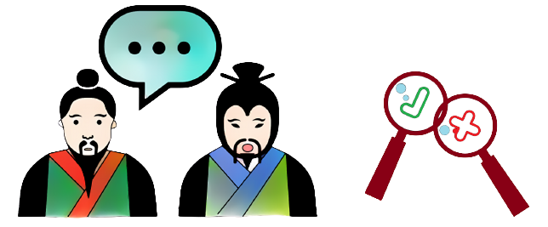
*The Warring States Period refers to a period of time (475 BC – 221 BC) in ancient history characterised by warfare.

1. What is the purpose of forming alliances during the Warring States Period?
a. To cease wars
b. To initiate wars
c. To attack each other
d. To weaken national power
Explanation/Hints:
Read paragraph 1.
“In order to avoid years of war, some states had signed friendship treaties with other states, forming alliances and no longer attacking one another.”

2. Which one from the State of Wei was sent to the State of Zhao as a hostage?
a. The king himself
b. The king’s son
c. The king’s daughter
d. The king’s father
Explanation/Hints:
Read paragraph 1.
“To show that the king of the state would definitely keep his promise, he would send his prince to another state as a hostage. Against this background, the Prince of Wei was sent to the State of Zhao as a hostage...”

3. How was the attitude of the people in the imperial palace towards Pang Cong?
a. Friendly
b. Caring
c. Hostile
d. Indifferent
Explanation/Hints:
Read paragraph 2.
“Pang Cong knew that there were often rumours in the imperial palace that would seriously slander him.”

4. What did Pang Cong worry about after he went to the State of Zhao?
a. The tiger would appear on the street.
b. The king would believe those people who slandered him.
c. He was not able to come back to the State of Wei.
d. People in the imperial palace would slander him.
Explanation/Hints:
Read paragraph 2.
“Pang Cong knew that there were often rumours in the imperial palace that would seriously slander him … He was afraid that the King of Wei would believe these rumours.”

5. In paragraph 3, “There is definitely no tiger on the street. But as the number of people spreading the rumours increases, people can't help believing them.” What does the word “them” refer to? It refers to …
a. the people.
b. the countries.
c. the rumours.
d. the tigers.
Explanation/Hints:
Read the sentence again to get the correct answer.

6. In paragraph 4, “After Pang Cong left the State of Wei, many people spoke ill of him in front of the king.” What does “spoke ill of” mean? It means that…
a. the people said he was ill.
b. the people praised him.
c. the people bad-mouthed him.
d. the people missed him.
Explanation/Hints:
Read paragraph 3.
“After I have gone to the State of Zhao, there must be many people who would take advantage of my absence, criticise and slander me in front of the lord.”

7. A synonym is a word or phrase that has the same or nearly the same meaning as another word or phrase in the same language. For example, “Please be careful not to be deceived by rumours!” The word “deceived” means “tricked”.

Read the following descriptions. Choose a synonym from the list given for each of the words underlined. Each option can be used once only.

A. uncertain B. unions C. dependable D. unhappiness

 | Description | Synonym
7a. | States attacked one another, which often resulted in weak national power and misery of people. | ( D )
7b. | Some states formed alliances and no longer attacked one another. | ( B )
7c. | "If another person said that there were tigers on the street, would the lord believe it?" The king replied, "Then I would be doubtful." | ( A )
7d. | We need to look for relevant evidence through reliable sources and make correct judgments based on facts. | ( C )

Explanation/ Hints:
Read the sentences carefully to understand their meanings.

8. Read paragraph 4. What was TRUE about the king?
a. He no longer trusted Pang Cong as he believed the rumours.
b. He had problems with his heart, which affected his judgment.
c. He assigned another important task to Pang Cong.
d. He was grateful for Pang Cong’s assistance in accompanying the prince.
Explanation/Hints:
Read paragraph 4.
“After Pang Cong left the State of Wei, many people spoke ill of him in front of the king. Although the king didn't believe it at first, as time passed by, his heart was shaken. After the prince and Pang Cong returned to the State of Wei, the king alienated Pang Cong and stopped appointing him as minister.”

9. What should we do when we encounter rumours?
a. Tell our family and friends about the hearsay.
b. Post the information on the Internet to let more people know.
c. Believe it without checking the authenticity of the information.
d. Be skeptical and search for truth from reliable sources.
Explanation/Hints:
Read paragraph 5.
“Instead of believing in hearsay, we need to look for relevant evidence through reliable sources and make correct judgments based on facts.”

10. What is the moral lesson of the story? Based on the story, which Chinese saying can you think of?

11. Information is easily accessible on the Internet nowadays. However, we may sometimes come across misinformation. If the misinformation spreads, people may be misled and the consequences can be serious. How can we differentiate facts from misinformation? What actions would you take when you come across information that is uncertain to you? Share them with your parents or classmates.

Extension Activity
Watch the video clip “Plogging”, which is about how an activity of jogging while picking up litter has gathered people across China to turn collective efforts into something good to their communities and the environment.

https://chinacurrent.com/story/22706/plogging-kyle-obermann

The activity “plogging” has become popular as it provides a way for people to exercise and clean the environment. People’s concerted efforts can make great contribution to society. What activities can you do with other people to help others or serve the community? Think and share your ideas or experiences with your parents or classmates.

Read the Chinese story and answer the following questions.

Waiting for More Hares to Dash Dead against the Stump

1. In ancient China, there was a young farmer whose family had made a living out of farming for many generations. Farmers used to sow in spring and harvest in autumn, and began to work at sunrise and finished at sunset. In good harvest years, they could have enough food to eat and enough clothing to wear. However, when there was a famine due to crop failure, they had to suffer from hunger. Life as a farmer was very tough, so the young farmer had always dreamed of having unexpected blessings.

2. One day, a big fat hare jumped out of the grass while the young farmer was working in the fields. It ran past him in a panic and accidentally bumped into a tree stump. Its neck was seriously broken and it was finally dead. The young farmer grabbed the hare and noticed that its eyes were severely infected. He said happily to himself, “Poor blind hare, I got you with no effort!”

3. When the farmer looked up, he realised that some hunters were hunting for animals near his fields. “Let’s go to the other side. There won’t be any animals here!” yelled the hunters. The farmer hid the hare at once. After the hunters left the place, the farmer took the hare home excitedly and cooked a delicious meal for himself.

4. That night the farmer thought, “My luck comes at last! I need not work hard now. All I have to do is wait every day by the stump to pick up the hare that runs into it. How wonderful it will be!” Becoming too lazy to work hard to change his life, the farmer relied on his luck from then on. He abandoned his fields, put away all his farming tools, stayed by the tree stump and wished to get other hares.

5. Waiting at the tree stump with no hares for months, the farmer went back to his fields with much disappointment. When he looked at the fields, he could not believe his eyes because all his fields were overgrown with weeds. Many people learnt about this young farmer and laughed at him for being unrealistic. The farmer learnt a lesson that if he wanted to achieve his goals, he had to work hard as miracles did not always take place.

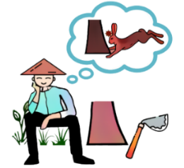

1. In paragraph 1, what is TRUE about the life of farmers?
a. They collected crops to eat in spring.
b. They put seeds in the fields in autumn.
c. They started working when the sun came out.
d. They returned home when the sun was very hot.
Explanation/Hints:
Read paragraph 1.
“In ancient China, there was a young farmer whose family had made a living out of farming for many generations. Farmers used to sow in spring and harvest in autumn, and began to work at sunrise and finished at sunset. In good harvest years, they could have enough food to eat and enough clothing to wear. However, when there was a famine due to crop failure, they had to suffer from hunger.”

2. In paragraph 1, what does “famine” mean? “Famine” means…
a. not having enough food for people to eat.
b. not having enough clothes for people to wear.
c. not having enough water for people to drink.
d. not having enough houses for people to live in.
Explanation/Hints:
Read paragraph 1.
“However, when there was a famine due to crop failure, they had to suffer from hunger.”

3. What was the problem of the poor hare?
a. It had difficulty in hearing.
b. It had difficulty in seeing.
c. It had difficulty in making sound.
d. It had difficulty in smelling.
Explanation/Hints:
Read paragraph 2.
“The young farmer grabbed the hare and noticed that its eyes were severely infected. He said happily to himself, ‘Poor blind hare, I got you with no effort!’ ”

4. What happened to the scared hare as there were people hunting nearby?
a. It got lost in the woods.
b. It hit the farmer hard.
c. It hit the stump hard.
d. It was caught by the hunters.
Explanation/Hints:
Read paragraph 2.
“One day, a big fat hare jumped out of the grass while the young farmer was working in the fields. It ran past him in a panic and accidentally bumped into a tree stump. Its neck was seriously broken and it was finally dead.”

5. What did the farmer do to the dead hare?
a. He took it home and cooked a meal for himself.
b. He buried it under the tree sadly.
c. He took it home and tried to save its life.
d. He brought it back to the woods.
Explanation/Hints:
Read paragraph 3.
“After the hunters left the place, the farmer took the hare home excitedly and cooked a delicious meal for himself.”

6. How did the farmer feel when he thought he might get other hares for free?
a. The farmer was worried.
b. The farmer was doubtful.
c. The farmer was scared.
d. The farmer was thrilled.
Explanation/Hints:
Read paragraph 4.
“That night the farmer thought, ‘My luck comes at last! I need not work hard now. All I have to do is wait every day by the stump to pick up the hare that runs into it. How wonderful it will be!’ ”

7. The word “too” means “more than enough”. The phrase “too adjective /adverb + to-infinitive” shows undesirable excess and has a kind of negative meaning.

Read the following descriptions. Fill in each blank with a phrase from the list given. Each option can be used once only.

- too excited to B. too lazy to C. too tough to D. too unrealistic to

 | Description | Phrase
7a. | The farmer had to work day and night. He thought it was _________________ be a farmer. | ( C )
7b. | As the hare dashed itself dead against the stump, the farmer was _________________ have a hare for dinner. | ( A )
7c. | The farmer was _________________ take care of his fields and the weeds grew higher and denser day after day. | ( B )
7d. | The farmer was _________________ wait for another hare to dash against the stump. He should have worked hard in his fields in order to have a better life. | ( D )

Explanation/Hints:
Read the sentences carefully to understand their meanings.

8. What happened to the farmer’s abandoned fields?
a. A lot of wild plants had grown in the fields.
b. A lot of crops were grown in the fields.
c. Some more hares were found dead in the fields.
d. There was a great harvest in the fields.
Explanation/Hints:
Read paragraph 5.
“When he looked at the fields, he could not believe his eyes because all his fields were overgrown with weeds.”

9. From the story, which of the following best describes the farmer after he got a big fat hare?
a. The farmer became selfish and never shared his food with his family.
b. The farmer became proactive and always tried new methods to farm.
c. The farmer became idle and gave up trying to farm.
d. The farmer became brave and always hunted wild animals for food.
Explanation/Hints:
Read paragraph 4.
“Becoming too lazy to work hard to change his life, the farmer relied on his luck from then on. He abandoned his fields, put away all his farming tools, stayed by the tree stump and wished to get other hares.”

10. What is the moral lesson of the story? Based on the story, which Chinese saying can you think of?

11. Miracles do not happen every day. To achieve our goals, we should work very hard. Do you have any goals? What will you do to achieve them? Share them with your parents or classmates.

Extension Activity
Watch the video clip “How Smart Farming Brings Social Good”, which is about the application of modern technology in China such as cloud computing and driverless vehicles to grow and harvest crops more sustainably.

https://chinacurrent.com/story/23773/how-smart-farming-brings-social-good
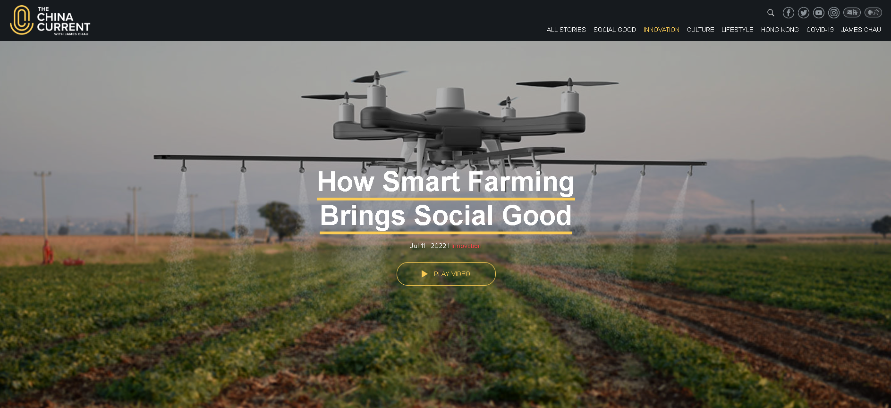

In the past, farmers worked very hard, but it did not guarantee good harvests. Thanks to modern technology, the work of farming has changed a lot, e.g. less physical labour and high yields during the harvest. What impresses you most in smart farming? Think and share your ideas or experiences with your parents or classmates.

Read the Chinese story and answer the following questions.

Yu Gong Moved away Two Mountains

1. A long time ago, there was a ninety-year-old man called Yu Gong, who lived in the north of two mountains. These two mountains, one called Taihang Mountain and the other Wangwu Mountain, stood in front of Yu Gong’s house. Whenever Yu Gong or his family had something to do on the other side of the mountains, they had to walk a long way round the two mountains and this caused much inconvenience. Yu Gong decided to move the two mountains away.

2. Yu Gong asked all his family members to sit together and they discussed how to remove the two mountains. His wife was worried and said, “You are ninety now. How can an old man like you move the two huge mountains away? Even if you can, where can you throw the earth and rocks?”

3. “If we work hard together, we can move the mountains away. For the earth and the rocks, we can throw them to the edge of the Sea of Bohai,” said Yu Gong. Led by Yu Gong, his children started to dig the mountains. They broke the rocks up, removed the earth and transported the rocks to the Sea of Bohai. An eight-year-old son of the neighbouring widow was glad to help Yu Gong and his sons and grandsons remove the earth and the rocks. They spent almost a year travelling back and forth to dump the rubble to the Sea of Bohai, and they still continued to dig the mountains.

4. One day, a wise old man called Zhi Sou was sitting near the bank of the Sea of Bohai when he saw Yu Gong and his children. He teased Yu Gong and said, “How silly you are! You are so old and weak. You can’t even take away the grass and trees. How can you remove the two high mountains?”

5. “You are wrong,” sighed Yu Gong. “Even if I die, my sons, my grandchildren, my great-grandchildren will continue my work. Generations after generations and there is no end. Look! These mountains will not grow taller. We shall be able to move them away one day!” Zhi Sou was tongue-tied as Yu Gong was so determined and confident.

6. Yu Gong and his children kept on with their work. The Emperor of Heaven was afraid that they would dig endlessly, and was also moved by Yu Gong’s determination, so he sent two gods down to help them remove the two mountains. Finally, Yu Gong’s dream came true.
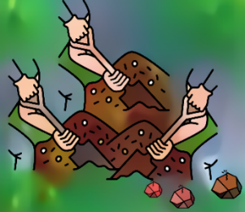

- Where did the old man live?
- The old man lived in the east of two high mountains.
- The old man lived in the south of two high mountains.
- The old man lived in the west of two high mountains.
- The old man lived in the north of two high mountains.
Explanation/Hints:
Which one is the correct direction?
Read paragraph 1.
“A long time ago, there was a ninety-year-old man called Yu Gong, who lived in the north of two mountains.”

- Why did the old man want to move the mountains away?
- The old man found it hard to get around the two mountains.
- The old man thought the two mountains were too rounded.
- The old man found it easy to get through the two mountains.
- The old man thought the two mountains were too short.
Explanation/Hints:
What did the old man think about the two mountains?
Read paragraph 1.
“These two mountains, one called Taihang Mountain and the other Wangwu Mountain, stood in front of Yu Gong’s house. Whenever Yu Gong or his family had something to do on the other side of the mountains, they had to walk a long way round the two mountains and this caused much inconvenience. Yu Gong decided to move the two mountains away.”

- Who did the old man ask for help with the removal of the mountains?
- The old man asked his wife and friends for help.
- The old man asked his sons and grandchildren for help.
- The old man asked his neighbours for help.
- The old man asked his old friends for help.
Explanation/Hints:
Who started to break up rocks and remove the earth?
Read paragraph 2.
“Yu Gong asked all his family members to sit together and they discussed how to remove the two mountains.”

- Where did the people deposit the earth and rocks?
- They moved the earth and rocks to places near the two mountains.
- They moved the earth and rocks to the Sea of Taihang.
- They moved the earth and rocks to the Sea of Wangwu.
- They moved the earth and rocks to the Sea of Bohai.
Explanation/Hints:
What is the name of the sea?
Read paragraph 3.
“ ‘If we work hard together, we can move the mountains away. For the earth and the rocks, we can throw them to the edge of the Sea of Bohai,’ said Yu Gong.”

- Based on what Yu Gong decided to do with the mountains, which adjectives best describe him?
- Determined
- Laid-back
- Optimistic
(iv) Reluctant
- (i) & (ii)
- (i), (ii) & (iii)
- (i) & (iii)
- (i), (iii) & (iv)
Explanation/Hints:
In Yu Gong’s opinion, who would help him remove the mountains?
Would they give up if they had difficulties removing the mountains?
Read paragraph 5.
“ ‘You are wrong,’ sighed Yu Gong. ‘Even if I die, my sons, my grandchildren, my great-grandchildren will continue my work. Generations after generations and there is no end. Look! These mountains will not grow taller. We shall be able to move them away one day!’ ”

- Based on what the widow’s son did for Yu Gong, which adjective best describes him?
- Selfish
- Supportive
- Careless
- Aggressive
Explanation/Hints:
How did the widow’s son feel when he offered help?
Read paragraph 3.
“An eight-year-old son of the neighbouring widow was glad to help Yu Gong and his sons and grandsons remove the earth and the rocks.”

- Some adjectives are formed with body parts to describe a person’s personality or character, e.g. “tight-lipped” describes a person who refuses to speak and keeps silent about something.

Read the following descriptions. Fill in each blank with an adjective from the list given. Each option can be used once only.

- stouthearted B. hardheaded C. warm-hearted D. tongue-tied

 | Description | Adjective
7a. | Yu Gong’s wife knew clearly that Yu Gong was an old man. She thought that Yu Gong’s suggestion of removing the mountains was not practical and unrealistic. She was a _______ person. | ( B )
7b. | Yu Gong decided to move the two mountains away, even if it took generations. Yu Gong was a _______person. | ( A )
7c. | Zhi Sou was surprised to find Yu Gong so determined and confident. Zhi Sou was ______. | ( D )
7d. | The Emperor of Heaven was moved by Yu Gong’s strong will. He finally made Yu Gong’s dream come true. He was _______. | ( C )

A: “Stouthearted” refers to a person who is brave and strong-minded.
B: “Hardheaded” refers to a person who is practical to get what he/she wants or needs, and does not allow emotions to affect his/her actions.
C: “Warm-hearted” refers to a person who is kind and loving.
D: “Tongue-tied” refers to a person who is hard to express himself/herself, usually because he/she is shocked or nervous.

- Why was Yu Gong so confident that he and his descendants could remove the mountains one day?
- Yu Gong said that the mountains would not grow taller, so he and his descendants could remove them if they kept digging.
- Yu Gong said that the mountains were so short that he and his descendants could remove them one day if they kept digging.
- Yu Gong said that his sons and descendants were young enough to remove the two tall mountains.
- Yu Gong said that all the gods would help him remove the two tall mountains if he and his descendants kept digging.
Explanation/Hints:
What did Yu Gong say to Zhi Sou?
Read paragraph 5.
“ ‘Look! These mountains will not grow taller. We shall be able to move them away one day!’ Zhi Sou was tongue-tied as Yu Gong was so determined and confident.”

- Which of the following is NOT TRUE about the story?
- Yu Gong was a 90-year-old man who lived in the north of two mountains.
- Yu Gong was positive that perseverance and hard work could lead to success.
- Zhi Sou supported Yu Gong by helping him move the two mountains away.
- Yu Gong was committed to his family by removing the mountains for them.
Explanation/Hints:
What did Zhi Sou do to the old man when he learned about the old man’s plan?
Read paragraph 4.
“One day, a wise old man called Zhi Sou was sitting near the bank of the Sea of Bohai when he saw Yu Gong and his children. He teased Yu Gong and said, ‘How silly you are! You are so old and weak. You can’t even take away the grass and trees. How can you remove the two high mountains?’ ”

- What is the moral lesson of the story? Based on the story, which Chinese saying can you think of?

- Have you ever had any successful experience before because you were determined, perseverant and did not give up? What was it? Share what you learnt from it with your parents or classmates.

Extension Activity
Watch the video clip “Wuyishan – China’s First National Parks”, which introduces the story of Wuyishan National Park, one of China’s first five official national parks.

https://chinacurrent.com/story/23978/wuyishan-chinas-first-national-parks-kyle-obermann

Being one of China’s first national parks, Wuyishan has many special features, e.g. scenic beauty, species richness, cultural significance and extraordinarily diverse geography. What impresses you most about Wuyishan? Why? Think and share your ideas or experiences with your parents or classmates.

Read the Chinese story and answer the following questions.

Yu the Great Tamed the Waters

1. Long, long ago, people suffered a lot from great floods. Sometimes they were so severe that even the houses collapsed, and crops and livestock were destroyed. Many people were left homeless and forced to flee to mountaintops. People’s lives were hard at that time.

2. Emperor Yao, who had always been known for his benevolence, did not want the people to suffer, so he appointed a distant relative named Gun to tackle the floods. Gun did everything possible to stop the ruthless floods. He spent nine years building embankments to block the raging water. However, this traditional way didn’t work well. Powerful floodwater breached the dike and brought disaster to the people. As the days passed, the floods continued. Therefore, the successor Emperor Shun appointed Gun’s son Yu as the commander-in-chief of flood control. Yu was clever, witty, hard-working, serious and responsible. He was also cordial and amiable to others. Having faith in his words, he was deeply loved by the people.

3. Yu understood that apart from blocking the flood, he should also do a good job in diverting the rivers. He led the people to go over the mountains, erecting wooden pillars as markers to measure the location and characteristics of the mountains and rivers. He also dredged and widened the rivers so as to divert the floods to the sea in the east.

4. No matter how hard and tiring the work was, Yu did his best to control the water so that the people could have a stable life. He always reminded himself to be frugal, and would rather live in a shabby room, and spend all the savings on water control. After getting married for four days, he hurriedly left his beautiful wife and continued to fight side by side with his companions. During the years he was away from home, Yu had passed by his home three times, but he didn’t allow himself to go inside and meet his family for fear of delaying his enormous task, even when he heard the wailings of his newborn son.

5. After years of hardship, Yu finally succeeded in opening roads to mountains and dredging big rivers. Not only were the floods stopped, but even the arid areas were also nourished by the rivers. The earth restored its prosperous scene, and the people finally enjoyed good years. Yu made selfless dedication to the people and became a hero highly admired and supported by them. They even called him Yu the Great to express their profound respect for him. Being impressed with the result of Yu’s flood control techniques and his attitude towards work, Emperor Shun chose Yu to be the successor to the throne after him. Yu the Great then founded the first dynasty in Chinese history: the Xia*.
*The Xia Dynasty refers to a dynasty in ancient Chinese history that ruled from about 2070 BC to 1600 BC.
1. People had to escape to the mountaintops because…
a. there was a great flood.
b. there were a lot of hills and valleys.
c. there was heavy rain.
d. they were homeless.
Explanation/Hints:
Read paragraph 1.
“Long, long ago, people suffered a lot from great floods ... Many people were left homeless and forced to flee to mountaintops.”

2. What was NOT TRUE about Gun?
a. He spent nine years building embankments to block the waters.
b. Emperor Yao appointed him to control the flood.
c. He was the emperor’s distant relative.
d. He successfully helped to control the waters.
Explanation/Hints:
Read paragraph 2.
“Emperor Yao, who had always been known for his benevolence, did not want the people to suffer, so he appointed a distant relative named Gun to tackle the floods. Gun did everything possible to stop the ruthless floods. He spent nine years building embankments to block the raging water. However, this traditional way didn’t work well.”

3. Read paragraph 2. Who was Yu?
a. The current emperor
b. Gun’s father
c. Gun’s son
d. The emperor’s friend
Explanation/Hints:
Read paragraph 2.
“As the days passed, the floods continued. Therefore, the successor Emperor Shun appointed Gun's son Yu as the commander-in-chief of flood control.”

4. What did Yu do to tame the flood?
a. He built embankments to block the raging water.
b. He let the floodwater breach the dike.
c. He led the people to go under the sea.
d. He dredged and widened the rivers to divert the floods to the sea.
Explanation/Hints:
Read paragraph 3.
“He led the people to go over the mountains, erecting wooden pillars as markers to measure the location and characteristics of the mountains and rivers. He also dredged and widened the rivers so as to divert the floods to the sea in the east.”

5. Which of the following statements is NOT TRUE about Yu?
a. He stayed frugal because he spent all the savings on water control.
b. He thought it was too hard and tiring to control the water and wanted to give up.
c. He left his beautiful wife for work after getting married for a few days.
d. He did his best to control the water because he wanted the people to have a stable life.
Explanation/Hints:
Read paragraph 4.
“No matter how hard and tiring the work was, Yu did his best to control the water so that the people could have a stable life. He always reminded himself to be frugal, and would rather live in a shabby room, and spend all the savings on water control. After getting married for four days, he hurriedly left his beautiful wife and continued to fight side by side with his companions.”
Taming the great floods was hard and tiring work. Did he try to give up the work?

6. Yu didn’t allow himself to see his family when he passed by his house because …
a. the emperor did not want him to do so.
b. he was afraid of the wailings of his newborn son.
c. he was afraid that this would delay his work.
d. his family did not allow him to do so.
Explanation/Hints:
Read paragraph 4.
“During the years he was away from home, Yu had passed by his home three times, but he didn’t allow himself to go inside and meet his family for fear of delaying his enormous task ...”

7. A compound word is made up of two or more different words to create a new word with a new meaning. For example, the word “livestock” in the story is made up of “live” and “stock”, which means animals and birds that are kept on a farm, such as cows, sheep, or chickens.

Read the following descriptions. Fill in each blank with a compound word from the list given. Each option can be used once only.

A. floodwater B. newborn C. commander-in-chief D. mountaintops

 | Description | Compound word
7a. | To escape from the flood, people ran up to the ___________ because they were the highest points that people could reach. | ( D )
7b. | The ___________ rose higher and higher. It covered the people’s houses, which made many people homeless. | ( A )
7c. | Yu was the ___________ of flood control. He was very hard-working and strongly committed to his work. After years of hardship, the floods were stopped and people enjoyed better lives. | ( C )
7d. | Yu did not have time to take care of his ___________ baby because he was too busy to control the flood. | ( B )

Explanation/Hints:
- The word “floodwater” is made up of “flood” and “water”, which means water that overflows as a result of a flood.
- The word “newborn” is made up of “new” and “born”, which means recently born.
- The word “commander-in-chief” is made up of “commander”, “in” and “chief”, which means a person who is in charge of all the armed forces of a country.
- The word “mountaintops” is made up of “mountain” and “tops”, which means the tops of mountains.

8. Read paragraph 5. What was NOT TRUE about Yu?
a. People called him “Yu the Great”.
b. Yu became the emperor of the Xia Dynasty.
c. People respected Yu very much.
d. Emperor Shun thought Yu could do better.
Explanation/Hints:
Read paragraph 5.
“They even called him Yu the Great to express their profound respect for him. Being impressed with the result of Yu’s flood control techniques and his attitude towards work, Emperor Shun chose Yu to be the successor to the throne after him. Yu the Great then founded the first dynasty in Chinese history: the Xia.”

9. People called Yu “Yu the Great” because …
a. he dedicated his time and effort to controlling the flood for the people.
b. he was the tallest, the cleverest and the strongest man in his country.
c. he built the biggest system of canals to help his family irrigate the fields.
d. he controlled the flood with the people and the emperor.
Explanation/Hints:
What did Yu do throughout his years of hardship?
Read paragraphs 3-5.
Did he stay frugal and spend all the savings on water control?
Did he work alongside the people to dredge the rivers?
Did he allow himself to see his family, including his newborn son, although he was near his house three times?
Yu made selfless dedication to the people, putting their safety as the first priority. What was he committed to?

10. What is the moral lesson of the story? Based on the story, which Chinese saying can you think of?

11. Yu was very determined to help other people. Have you ever helped others? Think of one incident and share it with your parents or classmates.

Extension Activity
Watch the video clip “Floods and Sponge Cities”, which is about some cities such as Zhengzhou in China having experienced horrific floods and developing “sponge” infrastructure to improve the situation.

https://chinacurrent.com/story/22606/floods-and-sponge-cities-kyle-obermann

A stitch in time saves nine. In the past, Yu the Great was determined to prevent flooding using his flood control techniques. What have the people in Zhengzhou done to make the flooding less harmful? Do you have any experience in helping others solve a problem? What was it and how did you fix it? Think and share your ideas or experiences with your parents or classmates.

